

Student Name | Swapnil Birajdar
SRN No | 31231287
Roll No | 41
Program | B.Tech AIDS
Year | Third Year
Division | A
Subject | Computer Network Laboratory (BTECCE21506)
Assignment No | 6

Assignment Number - 06

Title : Configuration of router for implementation of Open Shortest Path First (OSPF) Protocol

Problem Statement Using a Network Simulator (e.g. packet tracer) Configure routers for OSPF routing

Theory :
OSPF Protocol
OSPF is a complex routing protocol. It uses many terms to define its functions and operations.
Link
A link is a router's interface connected to an IP subnet. When we add an interface to the OSPF process, OSPF considers the interface as a link.
State
Since a link is an interface, it has two states: up and down. The up state shows the link (interface) is operational and OSPF can reach the IP subnet connected to the link. The down state shows the link is not operational and OSPF cannot reach the IP subnet connected to the link.
Link state protocol
OSPF is a link-state protocol. Link state protocols use the Shortest Path First (SPF) algorithm to calculate the best path to a destination. To run this algorithm, link-state protocols learn the complete topology of the network. In a big size network, this feature creates scalability problems. To solve this problem, OSPF uses two concepts: autonomous systems and areas.
An autonomous system
Term | Description
Backbone area | A special area to which all other areas must connect.
area | A set of contiguous routers that share the same routing information.
Backbone routers | Routers in the backbone area
Internal routers | Routers in areas off the backbone
ABR | A router that connects the area to the backbone area
Intra-area route | A route within the same area
Interarea route | A route between the areas
An autonomous system is a group of networks under a single administrative control which can be a group of companies, a company, or a division within the company. There are two types of routing protocols: Interior Gateway Protocol (IGP) and Border Gateway Protocol (BGP). IGP routing protocols provide routing within a single AS. BGP routing protocols provide routing between different AS. OSPF is a IGP routing protocol. OSPF provides routing within a single AS.

OSPF Area
OSPF groups network together, where the topology of one group is hidden from the other. These set of groups are called Areas. An area ID is 32 bit number, which is unique identification number that differentiates each area.
Backbone area (Area 0) – Responsible for distributing routing information among other areas of the system. The backbone area is identified by the number 0.0.0.0
Off backbone area (Area 1-65535) – consist of areas other than backbone area of system.

Configuration of OSPF
The systax for configuring OSPF is:
Router(Config)#router ospf process_ID
Router(Config)#network Network_address Wildcard_mask area are_no

OSPF Implementation with Single Area

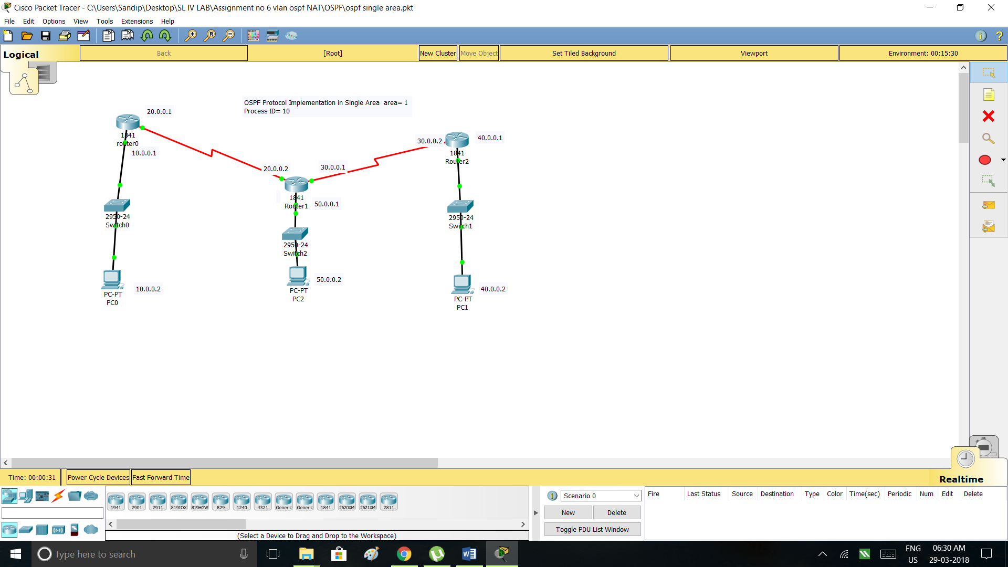

Code
OSPF Single Area
Router 0

Router(config)#interface FastEthernet0/0
Router(config-if)#ip address 10.0.0.1 255.0.0.0
Router(config-if)#no shutdown
Router(config-if)#
%LINK-5-CHANGED: Interface FastEthernet0/0, changed state to up
%LINEPROTO-5-UPDOWN: Line protocol on Interface FastEthernet0/0, changed state to up
Router(config)#interface Serial0/0/0
Router(config-if)#ip address 20.0.0.1 255.0.0.0
Router(config-if)#no shutdown
Router(config-if)#
%LINK-5-CHANGED: Interface Serial0/0/0, changed state to up
%LINEPROTO-5-UPDOWN: Line protocol on Interface Serial0/0/0, changed state to u

Router#show ip route
Codes: C - connected, S - static, I - IGRP, R - RIP, M - mobile, B - BGP
D - EIGRP, EX - EIGRP external, O - OSPF, IA - OSPF inter area
N1 - OSPF NSSA external type 1, N2 - OSPF NSSA external type 2
E1 - OSPF external type 1, E2 - OSPF external type 2, E - EGP
i - IS-IS, L1 - IS-IS level-1, L2 - IS-IS level-2, ia - IS-IS inter area
* - candidate default, U - per-user static route, o - ODR
P - periodic downloaded static route

Gateway of last resort is not set

C 10.0.0.0/8 is directly connected, FastEthernet0/0
C 20.0.0.0/8 is directly connected, Serial0/0/0
Router(config)#router ospf 10
Router(config-router)#network 10.0.0.0 0.255.255.255 area 1
Router(config-router)#network 20.0.0.0 0.255.255.255 area 1
Router#show ip route
Codes: C - connected, S - static, I - IGRP, R - RIP, M - mobile, B - BGP
D - EIGRP, EX - EIGRP external, O - OSPF, IA - OSPF inter area
N1 - OSPF NSSA external type 1, N2 - OSPF NSSA external type 2
E1 - OSPF external type 1, E2 - OSPF external type 2, E - EGP
i - IS-IS, L1 - IS-IS level-1, L2 - IS-IS level-2, ia - IS-IS inter area
* - candidate default, U - per-user static route, o - ODR
P - periodic downloaded static route

Gateway of last resort is not set
C 10.0.0.0/8 is directly connected, FastEthernet0/0
C 20.0.0.0/8 is directly connected, Serial0/0/0
O 30.0.0.0/8 [110/128] via 20.0.0.2, 00:01:55, Serial0/0/0
O 40.0.0.0/8 [110/129] via 20.0.0.2, 00:00:14, Serial0/0/0
O 50.0.0.0/8 [110/65] via 20.0.0.2, 00:02:06, Serial0/0/0

Router 1

Router(config)#interface FastEthernet0/0
Router(config-if)#ip address 50.0.0.1 255.0.0.0
Router(config-if)#no shutdown
Router(config-if)#
%LINK-5-CHANGED: Interface FastEthernet0/0, changed state to up
%LINEPROTO-5-UPDOWN: Line protocol on Interface FastEthernet0/0, changed state to up
Router(config)#interface Serial0/0/0
Router(config-if)#ip address 20.0.0.2 255.0.0.0
Router(config-if)#no shutdown
Router(config-if)#
%LINK-5-CHANGED: Interface Serial0/0/0, changed state to up

%LINEPROTO-5-UPDOWN: Line protocol on Interface Serial0/0/0, changed state to up
Router(config)#interface Serial0/0/1
Router(config-if)#ip address 30.0.0.1 255.0.0.0
Router(config-if)#no shutdown
Router(config-if)#
Router(config)#router OSPF 10
Router(config-router)#network 50.0.0.0 0.255.255.255 area 1
Router(config-router)#network 20.0.0.0 0.255.255.255 area 1
Router(config-router)#network 30.0.0.0 0.255.255.255 area 1
Router#show ip route
Codes: C - connected, S - static, I - IGRP, R - RIP, M - mobile, B - BGP
D - EIGRP, EX - EIGRP external, O - OSPF, IA - OSPF inter area
N1 - OSPF NSSA external type 1, N2 - OSPF NSSA external type 2
E1 - OSPF external type 1, E2 - OSPF external type 2, E - EGP
i - IS-IS, L1 - IS-IS level-1, L2 - IS-IS level-2, ia - IS-IS inter area
* - candidate default, U - per-user static route, o - ODR
P - periodic downloaded static route

Gateway of last resort is not set

O 10.0.0.0/8 [110/65] via 20.0.0.1, 00:02:49, Serial0/0/0
C 20.0.0.0/8 is directly connected, Serial0/0/0
C 30.0.0.0/8 is directly connected, Serial0/0/1
O 40.0.0.0/8 [110/65] via 30.0.0.2, 00:01:09, Serial0/0/1
C 50.0.0.0/8 is directly connected, FastEthernet0/0

Router2

Router(config)#interface FastEthernet0/0
Router(config-if)#ip address 40.0.0.1 255.0.0.0
Router(config-if)#no shutdown

Router(config-if)#
%LINK-5-CHANGED: Interface FastEthernet0/0, changed state to up
Router(config)#interface Serial0/0/0
Router(config-if)#ip address 30.0.0.2 255.0.0.0
Router(config-if)#no shutdown
Router(config-if)#
%LINK-5-CHANGED: Interface Serial0/0/0, changed state to up
Router(config)#router OSPF 10
Router(config-router)#network 30.0.0.0 0.255.255.255 area 1
Router(config-router)#network 40.0.0.0 0.255.255.255 area 1
Router(config-router)#
00:28:19: %OSPF-5-ADJCHG: Process 10, Nbr 50.0.0.1 on Serial0/0/0 from LOADING to FULL, Loading Done
Router#show ip route
Codes: C - connected, S - static, I - IGRP, R - RIP, M - mobile, B - BGP
D - EIGRP, EX - EIGRP external, O - OSPF, IA - OSPF inter area
N1 - OSPF NSSA external type 1, N2 - OSPF NSSA external type 2
E1 - OSPF external type 1, E2 - OSPF external type 2, E - EGP
i - IS-IS, L1 - IS-IS level-1, L2 - IS-IS level-2, ia - IS-IS inter area
* - candidate default, U - per-user static route, o - ODR
P - periodic downloaded static route

Gateway of last resort is not set

O 10.0.0.0/8 [110/129] via 30.0.0.1, 00:02:09, Serial0/0/0
O 20.0.0.0/8 [110/128] via 30.0.0.1, 00:02:09, Serial0/0/0
C 30.0.0.0/8 is directly connected, Serial0/0/0
C 40.0.0.0/8 is directly connected, FastEthernet0/0
O 50.0.0.0/8 [110/65] via 30.0.0.1, 00:02:09, Serial0/0/0

Router#show ip ospf
Routing Process "ospf 10" with ID 40.0.0.1
Supports only single TOS(TOS0) routes
Supports opaque LSA
SPF schedule delay 5 secs, Hold time between two SPFs 10 secs
Minimum LSA interval 5 secs. Minimum LSA arrival 1 secs
Number of external LSA 0. Checksum Sum 0x000000
Number of opaque AS LSA 0. Checksum Sum 0x000000
Number of DCbitless external and opaque AS LSA 0
Number of DoNotAge external and opaque AS LSA 0
Number of areas in this router is 1. 1 normal 0 stub 0 nssa
External flood list length 0
Area BACKBONE(0)
Number of interfaces in this area is 2
Area has no authentication
SPF algorithm executed 2 times
Area ranges are
Number of LSA 3. Checksum Sum 0x011ea0
Number of opaque link LSA 0. Checksum Sum 0x000000
Number of DCbitless LSA 0
Number of indication LSA 0
Number of DoNotAge LSA 0
Flood list length 0

Router#show ip ospf database
OSPF Router with ID (40.0.0.1) (Process ID 10)

Router Link States (Area 0)

Link ID ADV Router Age Seq# Checksum Link count
20.0.0.1 20.0.0.1 631 0x80000003 0x0078aa 3
40.0.0.1 40.0.0.1 531 0x80000003 0x006661 3
50.0.0.1 50.0.0.1 531 0x80000005 0x003f95 5
Router#show ip protocols

Routing Protocol is "ospf 10"
Outgoing update filter list for all interfaces is not set
Incoming update filter list for all interfaces is not set
Router ID 40.0.0.1
Number of areas in this router is 1. 1 normal 0 stub 0 nssa
Maximum path: 4
Routing for Networks:
30.0.0.0 0.255.255.255 area 0
40.0.0.0 0.255.255.255 area 0
Routing Information Sources:
Gateway Distance Last Update
20.0.0.1 110 00:10:51
40.0.0.1 110 00:09:11
50.0.0.1 110 00:09:11
Distance: (default is 110)

Router#show ip ospf interface
Serial0/0/0 is up, line protocol is up
Internet address is 30.0.0.2/8, Area 0
Process ID 10, Router ID 40.0.0.1, Network Type POINT-TO-POINT, Cost: 64
Transmit Delay is 1 sec, State POINT-TO-POINT, Priority 0
No designated router on this network
No backup designated router on this network
Timer intervals configured, Hello 10, Dead 40, Wait 40, Retransmit 5
Hello due in 00:00:08
Index 1/1, flood queue length 0
Next 0x0(0)/0x0(0)
Last flood scan length is 1, maximum is 1
Last flood scan time is 0 msec, maximum is 0 msec
Neighbor Count is 1 , Adjacent neighbor count is 1
Adjacent with neighbor 50.0.0.1
Suppress hello for 0 neighbor(s)
FastEthernet0/0 is up, line protocol is up
Internet address is 40.0.0.1/8, Area 0
Process ID 10, Router ID 40.0.0.1, Network Type BROADCAST, Cost: 1
Transmit Delay is 1 sec, State DR, Priority 1
Designated Router (ID) 40.0.0.1, Interface address 40.0.0.1
No backup designated router on this network
Timer intervals configured, Hello 10, Dead 40, Wait 40, Retransmit 5

OSPF Implementation in Multiple Area

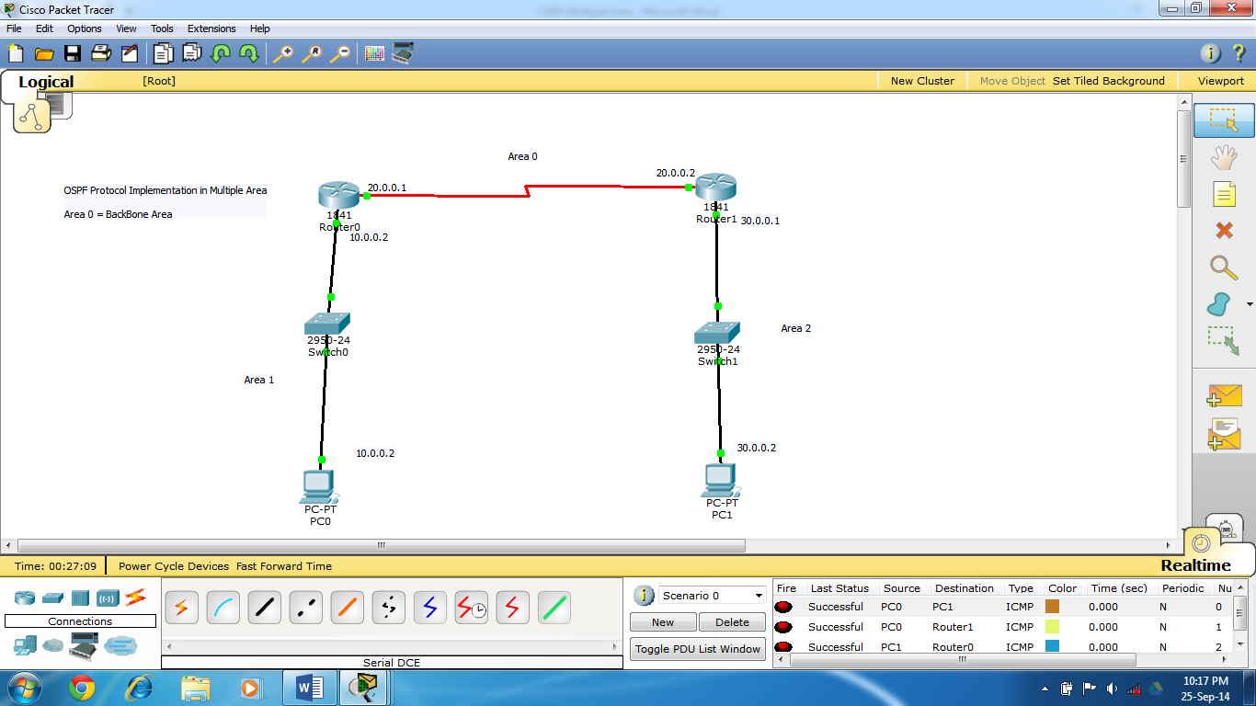
Code :
OSPF –Multiple Area
Router 0
Router>enable
Router#configure terminal
Enter configuration commands, one per line. End with CNTL/Z.
Router(config)#interface FastEthernet0/0
Router(config-if)#ip address 10.0.0.1 255.0.0.0
Router(config-if)#no shutdown
Router(config-if)#
%LINK-5-CHANGED: Interface FastEthernet0/0, changed state to up
%LINEPROTO-5-UPDOWN: Line protocol on Interface FastEthernet0/0, changed state to up
Router(config)#interface Serial0/0/0
Router(config-if)#ip address 20.0.0.1 255.0.0.0
Router(config-if)#clock rate 64000
Router(config-if)#no shutdown
Router(config-if)#
Router(config)#router ospf 10
Router(config-router)#network 10.0.0.0 0.255.255.255 area 1
Router(config-router)#network 20.0.0.0 0.255.255.255 area 0
Router#show ip route
Codes: C - connected, S - static, I - IGRP, R - RIP, M - mobile, B - BGP
D - EIGRP, EX - EIGRP external, O - OSPF, IA - OSPF inter area
N1 - OSPF NSSA external type 1, N2 - OSPF NSSA external type 2
E1 - OSPF external type 1, E2 - OSPF external type 2, E - EGP
i - IS-IS, L1 - IS-IS level-1, L2 - IS-IS level-2, ia - IS-IS inter area
* - candidate default, U - per-user static route, o - ODR
P - periodic downloaded static route

Gateway of last resort is not set

C 10.0.0.0/8 is directly connected, FastEthernet0/0
C 20.0.0.0/8 is directly connected, Serial0/0/0
O IA 30.0.0.0/8 [110/65] via 20.0.0.1, 00:01:14, Serial0/0/0

Router 1
Router>enable
Router#configure terminal
Enter configuration commands, one per line. End with CNTL/Z.
Router(config)#interface FastEthernet0/0
Router(config-if)#ip address 30.0.0.1 255.0.0.0
Router(config-if)#no shutdown

Router(config-if)#
%LINK-5-CHANGED: Interface FastEthernet0/0, changed state to up
%LINEPROTO-5-UPDOWN: Line protocol on Interface FastEthernet0/0, changed state to up
Router(config-if)#exit
Router(config)#interface Serial0/0/0
Router(config-if)#ip address 20.0.0.1 255.0.0.0
Router(config-if)#clock rate 64000
Router(config-if)#no shutdown
Router(config-if)#
%LINK-5-CHANGED: Interface Serial0/0/0, changed state to up
%LINEPROTO-5-UPDOWN: Line protocol on Interface Serial0/0/0, changed state to up
Router(config)#router ospf 10
Router(config-router)#network 20.0.0.0 0.255.255.255 area 0
Router(config-router)#network 30.0.0.0 0.255.255.255 area 1
Router#show ip route
Codes: C - connected, S - static, I - IGRP, R - RIP, M - mobile, B - BGP
D - EIGRP, EX - EIGRP external, O - OSPF, IA - OSPF inter area
N1 - OSPF NSSA external type 1, N2 - OSPF NSSA external type 2
E1 - OSPF external type 1, E2 - OSPF external type 2, E - EGP
i - IS-IS, L1 - IS-IS level-1, L2 - IS-IS level-2, ia - IS-IS inter area
* - candidate default, U - per-user static route, o - ODR
P - periodic downloaded static route

Gateway of last resort is not set

O IA 10.0.0.0/8 [110/65] via 20.0.0.1, 00:00:00, Serial0/0/0
C 20.0.0.0/8 is directly connected, Serial0/0/0
C 30.0.0.0/8 is directly connected, FastEthernet0/0

Router#show ip ospf
Routing Process "ospf 10" with ID 30.0.0.1
Supports only single TOS(TOS0) routes
Supports opaque LSA
It is an area border router
SPF schedule delay 5 secs, Hold time between two SPFs 10 secs
Minimum LSA interval 5 secs. Minimum LSA arrival 1 secs
Number of external LSA 0. Checksum Sum 0x000000
Number of opaque AS LSA 0. Checksum Sum 0x000000
Number of DCbitless external and opaque AS LSA 0
Number of DoNotAge external and opaque AS LSA 0
Number of areas in this router is 3. 3 normal 0 stub 0 nssa
External flood list length 0
Area 2
Number of interfaces in this area is 1
Area has no authentication
SPF algorithm executed 7 times
Area ranges are
Number of LSA 3. Checksum Sum 0x01983c
Number of opaque link LSA 0. Checksum Sum 0x000000
Number of DCbitless LSA 0
Number of indication LSA 0
Number of DoNotAge LSA 0
Flood list length 0
Area BACKBONE(0)
Number of interfaces in this area is 1
Area has no authentication
SPF algorithm executed 4 times
Area ranges are
Number of LSA 4. Checksum Sum 0x02a34f
Number of opaque link LSA 0. Checksum Sum 0x000000
Number of DCbitless LSA 0
Number of indication LSA 0
Number of DoNotAge LSA 0
Flood list length 0
Router#show ip ospf database
OSPF Router with ID (30.0.0.1) (Process ID 10)

Router Link States (Area 0)

Link ID ADV Router Age Seq# Checksum Link count
30.0.0.1 30.0.0.1 183 0x80000002 0x009fa8 2
20.0.0.1 20.0.0.1 183 0x80000007 0x00b894 2

Summary Net Link States (Area 0)
Link ID ADV Router Age Seq# Checksum
30.0.0.0 30.0.0.1 218 0x80000001 0x00f62a
10.0.0.0 20.0.0.1 331 0x80000002 0x0054e9

Router Link States (Area 1)

Link ID ADV Router Age Seq# Checksum Link count
20.0.0.1 20.0.0.1 316 0x80000004 0x0074a7 1
30.0.0.1 30.0.0.1 223 0x80000005 0x00f130 0

Summary Net Link States (Area 1)
Link ID ADV Router Age Seq# Checksum
30.0.0.0 30.0.0.1 189 0x80000001 0x00f62a
20.0.0.0 30.0.0.1 189 0x80000002 0x00f0f9
10.0.0.0 30.0.0.1 179 0x80000003 0x007a78

Router Link States (Area 2)

Link ID ADV Router Age Seq# Checksum Link count
30.0.0.1 30.0.0.1 223 0x80000002 0x0028cd 1

Summary Net Link States (Area 2)

Router#show ip protocols

Routing Protocol is "ospf 10"
Outgoing update filter list for all interfaces is not set
Incoming update filter list for all interfaces is not set
Router ID 30.0.0.1
Number of areas in this router is 3. 3 normal 0 stub 0 nssa
Maximum path: 4
Routing for Networks:
20.0.0.0 0.255.255.255 area 0
30.0.0.0 0.255.255.255 area 2
Routing Information Sources:
Gateway Distance Last Update
20.0.0.1 110 00:06:51
30.0.0.1 110 00:05:18
Distance: (default is 110)

Conclusion : <<Write Conclusion in your own words. Write about what you learn from OSPF protocol implementation >>

